13

Logistic regression

Running logistic regression using R

To illustrate running logistic regression in R will we use an example of participants who either are (coded ‘1’) or are not (coded ‘0’) receiving help for reading difficulties and with predictor variables of measures of short-term memory capacity (STM) and reading ability. The data are presented in Table 1:

Table 1
STM | ReadingAb | Intervention
2 | 77 | 0
20 | 73 | 0
5 | 73 | 0
4 | 68 | 0
19 | 55 | 0
7 | 92 | 0
17 | 55 | 0
20 | 55 | 0
9 | 60 | 0
18 | 120 | 0
18 | 56 | 0
14 | 84 | 0
19 | 60 | 0
2 | 85 | 0
15 | 93 | 0
12 | 60 | 0
16 | 65 | 0
6 | 58 | 0
20 | 85 | 0
17 | 67 | 0
11 | 65 | 1
19 | 93 | 1
6 | 52 | 1
14 | 42 | 1
1 | 75 | 1
12 | 48 | 1
16 | 64 | 1
1 | 66 | 1
16 | 82 | 1
14 | 52 | 1
14 | 45 | 1
13 | 57 | 1
3 | 65 | 1
2 | 46 | 1
6 | 75 | 1
9 | 100 | 1
2 | 77 | 1
8 | 51 | 1
18 | 62 | 1
1 | 44 | 1

Once you have imported this data into R (we have stored it in a data frame called ‘LogReg’) you can use the glm() command to run the logistic regression analysis (remember to use attach(LogReg) to make referring to variables easier):

>summary(glm(Intervention~STM+ReadingAb, family=binomial))

The last argument (family=binomial) indicates that the analysis should use the binomial distribution to evaluate the model fit (this is the appropriate distribution for logistic regression). When you run this command, you will be presented with the following output (Screenshot 1):

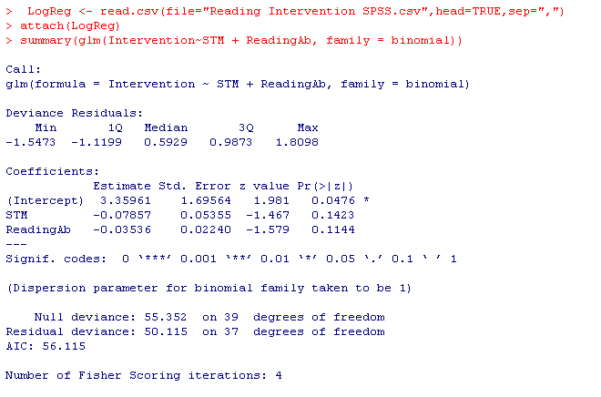

Screenshot 1

From this output we can see that neither STM nor ReadingAb are significant predictors of which intervention condition a participant was in. You will notice that unlike SPSS you do not t get an indication of whether the overall model is significant from the output of the glm() command. In order to get this information, you need to compare the model where you have the predictors included (as in Screenshot 1) with a model where there are no predictors. The way we do this is to run two regression analyses and to store the outputs in two different variables. We can then use the anova() command to compare these two outputs to see if the model with predictors in is significantly better at predicting group membership than the model without predictors. The commands we use are:

>glm1 <- glm(Intervention~STM+ReadingAb, family=binomial)

>glm0 <- glm(Intervention~1, family=binomial)

>anova(glm0, glm1, test=”Chisq”)

In these commands the ‘glm1’ and ‘glm0’ are simply the names we have chosen for the variables where we store the outputs from the two regression analyses. The ‘1’ in the second glm() command indicates that there are no predictor variables in this model. Finally, the anova() command compares the glm0 with the glm1 models to see if there is a significant difference between them. When you run these commands you will get the output presented in Screenshot 2:

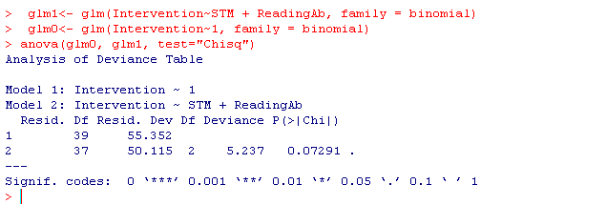

Screenshot 2

You can see from the output by consulting the ‘P(>|Chi|) column that the p-value of .073 indicates that the model with the two predictor variables does not predict group membership significantly better than the model without the predictor variables, and so this is not a particularly good regression model. When reporting these, you should report the value under the ‘Deviance’ column (in this case 5.237) as a chi-square value with 2 degrees of freedom and an associated p-value of .073.

You should also notice that unlike SPSS you do not automatically get the odds ratios for each predictor variable. To generate these values, you simply need to use the exp() command and include the ‘glm1’ variable name in the brackets thus:

>exp(glm1)

will give you the odds ratios (equivalent to the Exp(B)s in SPSS; see Screenshot 3):

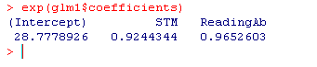

Screenshot 3
You will see from Screenshot 3 that we have an odds ratio for STM of 0.92. This means that as STM capacity increases, there is a decrease in the probability of a participant being in the reading intervention group. There is a similar odds ratio for the ReadingAb variable.

Using categorical predictors
Specifying models with categorical predictors is rather complicated in R and is beyond the scope of this introduction to the software.

